AMELIORATIVE EFFECTS OF SELENIUM AND VITAMIN C ON NICOTINE- INDUCED HEMATOTOXICITY, OXIDATIVE DAMAGE AND REPRODUCTIVE TOXICITY IN MALE ALBINO RATS
Rana M M Refaat ª, Atef E. Fouda ª, Mohamed A. El-Shishtawy ª, Adarsh Kumar ^{b} and Rabab F. Hindawy ª
ª Forensic Medicine and Clinical Toxicology Department, Faculty of Medicine, Benha University, Benha, 13518, Egypt.
^{b} Forensic medicine and Toxicology Department, All India Institute of Medical Sciences (AIIMS) -New Delhi- India.

Corresponding Author: Rana MM Refaat
Email: ronamedhat1221@gmail.com. 00201020122959
Abstract
Background: Nicotine abuse through cigarette smoking is a major public health problem. Nicotine induces a production of free radicals and consequently oxidative stress. Selenium is a micronutrient and element present in trace amounts in living organism. Vitamin-C (Ascorbic acid) is a water-soluble antioxidant which has a multifunction. It helps to strengthen the immune system and it prevents some diseases, play important role in the brain, nervous system, and immune system. Aim of work: The current study aimed to investigate the effects the toxic effects of nicotine and to evaluate the role of Selenium and Vitamin C in protecting the hemo-toxicity, hormonal toxicity, reproductive system toxicity and oxidative damage induced by nicotine in experimental animals represented in adult male albino rat. Material and methods: This work was performed on 66 adult male albino rats weighing between 100-120 mg. The animals were divided into 7 groups, each containing 6 animals. All groups were treated daily, for 4 weeks. The Study Design was distributed as: Negative control group, Positive control group, Nicotine group, Selenium group, Vitamin C group, Nicotine with Selenium group and finally Nicotine with Vitamin C group. Results: Our results displayed significantly that oral administration of Nicotine induced toxic effects, hormonal changes and hematological damage in the testes and these adverse effects may be attributed to induction of oxidative stress. Administration of Selenium and Vitamin C with Nicotine, protected against Nicotine damaging effect.

Key words: Nicotine, Selenium, Vitamin C, Oxidative process, and toxicity.

- INTRODUCTION
Nicotine is one of the most used illicit drugs (Carstens and Carstens, 2021). By 2030, it is estimated that tobacco use will kill more than 8 million people worldwide each year if current trends continue (Deniz et al., 2021). It is now considered to be one of the most insidiously addicting substances because most users of nicotine develop rapid tolerance for it and have extremely long‑lasting craving for it when trying to stop. Studies have shown that nicotine can induce tolerance and physical dependence (Tannous, et al., 2021). Nicotine induces a production of free radicals and consequently oxidative stress. People who smoke and who are exposed to cigarette smoke indirectly by breathing the air in the same environment are exposed to nicotine induced oxidative stress (Leventhal, et al., 2023).
Selenium is a micronutrient and element present in trace amounts in living organisms. Its properties range from essentiality to toxicity based on the dose and species considered. For these reasons, there is ongoing debate concerning its role in human health (Vinceti et al., 2021). It has antioxidant and pro-oxidant properties. Selenium may adversely affect cellular redox status via direct oxidation of thiol groups and indirect generation of reactive oxygen species (ROS) (Urbano, et al., 2023).
Vitamin C is an important dietary antioxidant which significantly decreases the adverse effects of ROS formed in the cell. Many biochemicals, clinical and epidemiologic studies have indicated that vitamin C may be of benefit in chronic diseases such as cardiovascular disease, cancer, and cataract, probably through antioxidant mechanisms (Chen, et al. ,2020). Vitamin C also contributes to the support of spermatogenesis at least in part through its capacity to reduce α-tocopherol and maintain this antioxidant in an active state. Vitamin C is itself maintained in a reduced state by a Glutathione-dependent dehydroascorbate reductase, which is abundant in the testes. Deficiencies of vitamins C led to a state of oxidative stress in the testes that disrupts both spermatogenesis and the production of testosterone (Yoo, et al., 2020).
2.AIM OF THE WORK
The aim of this study was to investigate the effects the toxic effects of nicotine and to evaluate the role of Selenium and Vitamin C in protecting the hemo-toxicity, hormonal toxicity, reproductive system toxicity and oxidative damage induced by nicotine in experimental animals represented in adult male albino rat.

3. MATERIALS AND METHODS
The experimental design study was approved by the Research Ethics Committee at Faculty of Medicine, Benha University (REC-FOMBU), Egypt. with approval number MD 4.10.2020.
3.1 Animals
This study was conducted on 42 healthy adult male albino rats, their average main weight was ranging between 130 gm to 200 gm.
At the animal bread house in the Benha Faculty of Veterinary, all the animals underwent one week of passive preliminaries (taking food and water without any medications) before beginning the experiment, to ascertain their physical wellbeing, and to exclude any diseased animals. The identical diet was given to all the animals (Wheat, Bread & Milk). For all animals, medication administration was scheduled to begin at 12 p.m. The animals were anesthetized with ether and killed 24 hours after the final dose was administered.
3.2 Chemicals
All drugs, reagents and chemicals used in this study area of analytical grade or higher purity was obtained from Sigma Chemical Co. through EICI and HIMEDIA lab chemicals & biochemicals. a. Nicotine: Nicotine hydrogen tartrate (NHT) is a biodegradable polymer of chitosan. NHT is more stable than nicotine. b. Selenium (Se): Selenium was in the form of sodium selenite c. Vitamin C: Vitamin C (100%) purity was in the form of L- ascorbic acid available in powdered crystalline solids with white color and molecular weight 176.13 g/mole and specific gravity 1.65.
3.3 Duration of the study
All groups were treated daily, for 4 weeks.
3.4 Grouping and experimental design
*The animals were divided into 7 groups, each containing 6 animals as follows:
- Negative control group: These rats were fed with normal protein diet containing 18% casein, 70% carbohydrate, 7% fat, 4% salt mixture, and 1% vitamin mixture.
- Positive control group (Solvent group): Nicotine hydrogen tartrate salt was dissolved in normal saline water and injected intraperitoneal to the animals for 4 weeks.
- Nicotine group: These rats were fed with normal protein diet and treated with effective dose of nicotine hydrogen tartrate salt (2.5 mg/kg body weight) for 4 weeks dissolved in 0.9% saline water with concentration (1:1) and was administrated via the intra-peritoneal route.
- Selenium group: These rats were fed with normal protein diet and treated with effective dose of sodium selenite (3 mg/kg body weight) for 4 week dissolved in distilled water with concentration (1:1).
- Vitamin C group: These rats were fed with normal protein diet and treated with effective dose of Vitamin C in the form of L- ascorbic acid was given in a dose 27 mg/rat/day orally dissolved in distilled water with concentration (1:1).
- Nicotine and Selenium group: These rats were fed with normal protein diet and treated with effective dose of nicotine (2.5 mg/kg body weight) followed by supplementation of effective dose of sodium selenite (3 mg/kg body weight) orally for 4 weeks.
- Nicotine and Vitamin C group: These rats were fed with normal protein diet and treated with effective dose of nicotine hydrogen tartrate salt (2.5 mg/kg body weight) followed by supplementation of effective dose of Vitamin C in the form of L- ascorbic acid was given in a dose 27 mg/rat/day orally dissolved in distilled water with concentration (1:1) orally for 4 weeks.
3.5 Parameters of the study:
- Body weight and relative weight of testis: Body weights at the beginning and end were noted. Rats were dissected, their testes were taken out and stripped of fatty tissues and blood vessels, blotted, and their weights were calculated after the experimental period.
- Reproductive abnormality (Semen analysis):
  - Sperm motility: The development of sperm motility was investigated according to the method reported by (Mosbah, et al., 2015).
  - Sperm livability: This was assessed, and the percentage calculated according to (Oyeyemi et al., 2011).
  - Sperm count and concentration: This was accomplished using the technique used by (Bearden and Fuquay, 1984).
  - Sperm abnormalities: This was recorded according to Evans and Maxwell (1987).
- Biochemical study for hormonal analysis: Blood samples were taken from their hearts by 5 ml syringes for estimation (FSH, LH and testosterone). Hormonal concentration was measured in the organs (Testis) and serum using the enzyme linked immuno-sorbant assay (ELISA) kits (Picard et al., 2008). and levels was detected, using VIDAS apparatus (BIOMERIEUX Company, France). The collected sera were stored for detection of hormonal levels by using ELISA kits.
- Hematological analysis: Red blood cells and White blood cells count and Hemoglobin level will be measured manually by routine methods, namely hemo-cytometry and spectrophotometry.
- Biochemical study for oxidative stress markers: Antioxidant enzymes: Superoxide dismutase enzyme (SOD), Catalase enzyme (CAT), reduced glutathione enzyme (GSH) and Malondialdehyde (MDA). The oxidative stress parameters will be analyzed by Spectro-nanodrop. Determination of SOD, MDA, CAT and GSH level in testicular tissue.
- Histopathological study by light microscope:
As indicated by Feldman and Wolfe (2014) A specimen from the right testis of each animal was removed and dropped in aqueous Bouin’s fluid. After fixation for 48 h, tissues were dehydrated through a graded series of ethanol, cleared in xylene, and embedded in paraffin. Sections of 5 um thick was obtained from paraffin blocks using a rotatory microtome. Then, they were mounted on a microscope slide, stained with haematoxylin–eosin (HE) and examined under light microscopy.
Statistical analysis:
Using SPSS [Statistical bundle for social science] version 20, the data had been collected, tabulated, and analyzed. For quantitative data, the mean and standard deviation were added; for subjective data, recurrence and dissemination were. The recognized significance level in this investigation started at 0.05. Student's t-test was used to compare between mean of two groups of numerical (parametric) data, Mann-Whitney U- test was used for continuous non- parametric data, ANOVA (analysis of variance) was used to compare between more than two groups of numerical (parametric) data, Kruskal Wallis test was used for continuous non- parametric data and Post hoc test for intergroup comparisons.
4.RESULTS
4.1. Body weight and relative weight of testis:

Table (1): Comparison between Positive control, negative control, Nicotine, Nano Selenium, Nano selenium/ Vitamin C regarding body weight and testis weight.
Group

 | Negative control |  | Positive control |  | Selenium |  | Vitamin C |  | Nicotine |  | P value
 | Mean | SD | Mean | SD | Mean | SD | Mean | SD | Mean | SD
Body weight | 233.33 | 25.2 | 232.5 | 13.59 | 211.67 | 17.15 | 262.67 | 20.88 | 126.33 | 14.19 | <0.001*
Testis weight | 0.42 | 0.13 | 0.47 | 0.1 | 0.42 | 0.06 | 0.48 | 0.07 | 0.35 | 0.7 | 0.1

As shown in table (1) at the end of experiment at the end of the 4th week (Final body weight) there was statistically significant increase was showed in all the studied groups as negative control, positive control Selenium, Vitamin C, Nicotine with Selenium and Nicotine with vitamin C all showed increase in body weight while Nicotine group decreased in body weights while the Mean value of epididymal weight showed no significant difference at the end of the 4 weeks between the studied groups as negative control positive control, Selenium, Vitamin C, Nicotine with Selenium and Nicotine with vitamin C showed slight increase while the Nicotine group showed decrease than the other groups.

4.2 Reproductive abnormality (semen analysis)

Table (2): Comparison between Negative control, Nicotine, Nicotine with Se, Nicotine with vitamin C regarding Reproductive abnormality.
Group  Semen  analysis | Negative control |  | Nicotine |  | Nicotine with Selenium |  | Nicotine with  vitamin C |  | P value
 | Mean | +SD | Mean | +SD | Mean | +SD | Mean | +SD
Motility (%) | 81.67 | 5.16 | 10.67 ª | 9.83 | 60.83 ^{a, b} | 4.92 | 73.33 ^{b, c} | 9.31 | <0.001*
Sperm count (million) | 40 | 7.75 | 8.83 ª | 7.98 | 14.08 ª | 9.28 | 31.17 ^{b, c} | 18.65 | <0.001*
Livability (%) | 93.37 | 3.01 | 28.42 ª | 7.38 | 32.78 ª | 2.54 | 82.01 ^{a, b, c} | 8.16 | <0.001*
Normal cells (%) | 81.83 | 7.38 | 28.73 ª | 17.03 | 55.78 ª | 6.6 | 67.9 ^{b, c} | 19.33 | <0.001*
Head abnormality (%) | 1.76 | 0.36 | 42.16 ª | 15.34 | 9.97 ª | 14.4 | 9 ^{b, c} | 12.97 | <0.001*
Tail abnormality (%) | 14.67 | 5.14 | 31.2 ª | 11.93 | 20.17 ª | 19.34 | 19.11 ^{c} | 8.35 | 0.03*
* Statistically significant (S).
ª significant from Negative control, ^{b} significant from Nicotine, ^{c} significant from Nicotine with Selenium.

Figure (1): Bar chart shows comparison between Negative control, Nicotine, Nicotine with Selenium and Nicotine with Vitamin C regarding semen analysis.

as shown in table (2) and figure (1) there was highly significant reduction in the mean value of Nicotine group when compared with Negative control group regarding sperm count, motility, livability, and normal cells while it showed highly significant increase regarding Head and Tail abnormality. Nicotine with selenium group showed a highly significant difference in the mean value when compared with Negative control group and nicotine group regarding livability, sperm count, motility, Livability, normal cells and head and tail abnormality. Nicotine with Vitamin C with Nicotine showed a highly significant difference in the mean value when compared with Control group, Nicotine group and vitamin C group. This study showed that Vitamin C group showed better results in the semen analysis when compared with Selenium group.

4.3 Hormonal analysis
Table (3): Comparison between Negative control, Nicotine, Nicotine with Se, Nicotine with vitamin C regarding Hormonal assay.
Group  Hormone | Negative control |  | Nicotine |  | Nicotine with Selenium |  | Nicotine with  vitamin C |  | P value
 | Mean | +SD | Mean | +SD | Mean | +SD | Mean | +SD
Follicular Stimulating Hormone (FSH) (U/ml) | 0.13 | 0.01 | 1.31 | 2.85 | 0.12 | 0.04 | 0.16 | 0.06 | 0.4
Luteinizing Hormone (LH)  (U/ml) | 0.6 | 0.1 | 7.37 ª | 6.92 | 0.66 ^{b} | 0.38 | 0.57 ^{b} | 0.29 | 0.005*
Testosterone (Free)  (pg/ml) | 57.08 | 11.16 | 29.15 ª | 11.09 | 73.17 ^{b} | 8.61 | 68.67 ^{b} | 28.54 | <0.001*
* Statistically significant (S). ª significant from Negative control, ^{b} significant from Nicotine, ^{c} significant from Nicotine with Selenium.

Figure (2): Clustered column chart show the comparison between Negative control, Nicotine, Nicotine with Selenium, Nicotine with vitamin C regarding Hormonal assay.

As shown in table (3) and figure (2) On the subject of Follicular stimulating hormone (FSH) there was no statistically significant difference between the compared groups of Negative control, Nicotine, Nicotine with Selenium and Nicotine with vitamin C. Regarding Luteinizing hormone (LH) Nicotine group showed statistically significant increase in the mean value when compared with Negative control group while Nicotine with selenium group and Nicotine with Vitamin C group both showed statistically significant decrease when compared with the nicotine group. As for Free testosterone Nicotine group showed statistically significant decrease in the mean value when compared with Negative control group, while Nicotine with selenium group and Nicotine with Vitamin C group both showed statistically significant increase when compared with the nicotine group. Our present study showed that co-administration of selenium with nicotine had better results than vitamin C with nicotine.

4.4 Haematological analysis
Table (4): Comparison between Negative control, Nicotine, Nicotine with Selenium and Nicotine with vitamin C regarding Hematological profile.
Group  CBC | Negative control |  | Nicotine |  | Nicotine with Selenium |  | Nicotine with  vitamin C |  | P value
 | Mean | +SD | Mean | +SD | Mean | +SD | Mean | +SD
Red cell count  (x10¹² /L) | 8.61 | 0.46 | 7.42 ª | 0.88 | 8.42 ^{b} | 0.83 | 8.39 ^{b} | 0.59 | 0.04*
Hemoglobin (g/dl) | 18.18 | 0.72 | 14.02 | 1.09 | 18.9 ^{b} | 1.55 | 16.72 ^{c} | 1.68 | 0.001*
Total leukocyte count (x10⁹/L) | 12.47 | 1.25 | 22.4 ª | 2.43 | 17.98 ^{a, b} | 2.12 | 15.63 ^{a, b} | 1.99 | <0.001*
* Statistically significant (S). ª significant from Negative control, ^{b} significant from Nicotine, ^{c} significant from Nicotine with Selenium.

Figure (3): Clustered column chart show comparison between Negative control, Nicotine, Nicotine with Selenium, Nicotine with vitamin C regarding Hematological profile.

As shown in table (4) and figure (3) regarding red cell count there was statistically significant decrease of the mean value of nicotine when compared with the control groups while Nicotine with selenium group showed statistically significant increase when compared with nicotine only group. Moreover, the coadministration of vitamin C with nicotine showed statistically significant increase when compared with the nicotine group only. As for Hemoglobin Coadministration of nicotine with selenium showed statistically significant increase when compared with the nicotine group and Coadministration of nicotine with vitamin C showed statistically significant increase when compared with the nicotine with selenium group. Regarding Total leukocyte count showed statistically significant increase of the mean value of nicotine group when compared with the control groups, Nicotine with Selenium group showed statistically significant decrease when compared with the control and nicotine group, while coadministration of Vitamin C with nicotine showed statistically significant decrease when compared with the nicotine group but the mean value was still higher than control group (showed a highly significant difference with control).

4.5 Oxidative parameters
Table (5): Comparison between Negative control, Nicotine, Vitamin C and Nicotine with Vitamin C. regarding Oxidative parameters.
Group  Oxidative  parameters |  | Negative control |  | Nicotine |  | Nicotine with Selenium |  | Nicotine with  vitamin C |  | P value
 |  | Mean | +SD | Mean | +SD | Mean | +SD | Mean | +SD
Tissue | MDA (nmol/gm) | 53.73 | 8.06 | 361.31 ª | 11.93 | 158.36 ^{a, b} | 46.75 | 247.66 ^{a, b, c} | 77.18 | <0.001*
 | CAT (U/gm) | 532.2 | 51.35 | 392.12 ª | 42.48 | 737.16 ^{a, b} | 170.45 | 640.22 ^{b} | 75.73 | <0.001*
 | GSH (mg/gm) | 10.54 | 0.92 | 4.97 ª | 0.66 | 7.25 ^{a, b} | 0.64 | 5.91 ^{a, c} | 1.12 | 0.001*
 | SOD (U/gm) | 427 | 23.29 | 350.6 | 80.82 | 387.98 | 102.39 | 350.16 ª | 18.49 | 0.049*
* Statistically significant (S). ª significant from Negative control, ^{b} significant from Nicotine, ^{c} significant from Nicotine with Selenium.

Figure (4): Clustered column chart shows the comparison between Negative control, Nicotine, Vitamin C and Nicotine with Vitamin C. regarding Oxidative parameters in tissue.

As shown in table (5) and figure (4) regarding MDA concentrations in tissue there was statistically significant increase of the mean value of nicotine when compared with the control group, Nicotine with selenium group showed statistically significant decrease when compared to the control group and nicotine group while the Nicotine with vitamin C showed statistically significant increase when compared with the control group and Nicotine with selenium and statistically significant decrease when compared with the nicotine. As for CAT concentrations in tissue there was statistically significant decrease of the mean value of nicotine when compared with the control group, Nicotine with selenium group showed statistically significant increase when compared to the control group and nicotine group while the Nicotine with vitamin C showed statistically significant decrease when compared with the nicotine group. Regarding GSH concentrations in tissue there was statistically significant decrease of the mean value of nicotine when compared with the control group, Nicotine with selenium group showed statistically significant increase when compared to the nicotine group and statistically significant decrease when compared to the control group, while the Nicotine with vitamin C showed statistically significant decrease when compared with the control group and nicotine with selenium group. Regarding SOD concentrations in tissue there was statistically significant decrease of the mean value of nicotine with vitamin c when compared with the control group. From our results regarding oxidative parameters, we found that the co administration of selenium with nicotine is better than the coadministration of Vitamin C.

4.6. Histopathological analysis
The examination of the testes by H&E-stained sections examined under the power 100 and 400 of control rats (positive and negative) in groups (1), (2) showed normal histological architecture. The parenchyma of testes was formed of the well-arranged seminiferous tubules and interstitial tissue in between, seminiferous tubules are normal with oval or rounded in outline. The germinal epithelium is mitotically active and showed different stages of maturation, arranged in many layers from basement membrane toward the lumen of the tubules, the three types of spermatogonia can be recognized, lumen is filled with spermatids and spermatozoa. Each tubule is surrounded by fibrous lamina called tunica. The limited interstitial spaces are filled with groups of well-arranged groups of pale stained interstitial Leydig cells normal interstitial tissue with no vacuolization, normal non congested blood vessels and no interstitial oedema (Figure 5). At the same time, the testis of rats treated with Selenium, Vitamin c, (groups (4) & (5)) showed preserved histological structure, with no vacuolization, normal non congested blood vessels and no interstitial oedema. (Figures 6&7).
Testis of rat group treated with Nicotine alone (group 3) showed marked loss of testicular tissue architecture seminiferous tubules with some spermatogonia not in order as in control rats. They appear scattered and only partially surrounding the whole seminiferous tubule. Large numbers of seminiferous tubules showed evident hypocellularity of all stages with decreased numbers and sometimes absent of spermatids and mature sperms, tubular degeneration, and intercellular vacuolization which means extensive degeneration. Varying degrees of germ cell degenerative changes were observed, ranging from loss of elongated spermatids, disorganization of germ cell layers, detachment and sloughing to vacuolization of the seminiferous tubules, contributing to eventual atrophy with defoliation of many spermatocytes into lumen of the ST (Figures 8 &9).
While in rat group received Vitamin C concomitant with Nicotine (group 7), mild improvement in histopathological findings was detected as there was mild restore to architecture of seminiferous tubules; germ cells lined the whole seminiferous tubule appearing mitotically active and showed different stages of maturation, arranged in many layers from basement membrane toward the lumen of the tubules, few focal spermatogenic arrest noticed with much less atrophy and vacuolation (Figure 10). However, in rat group received Selenium concomitant with Nicotine (group 6), the improvement in histopathological findings was less than that was seen in Nicotine with Vitamin C treated group, as most seminiferous tubules appear with very mild restore to architecture of seminiferous tubules with intercellular vacuoles, less numbers of spermatocytes and sperms filling lumen and less atrophy (Figure 11).

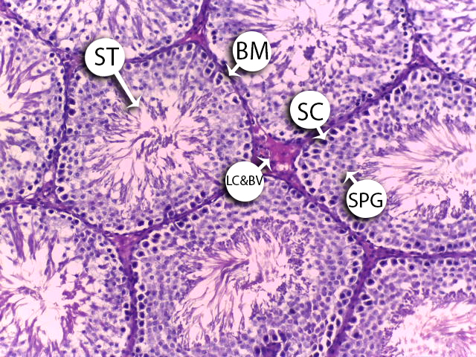
Figure (5): A photomicrograph of a section from rat’s testis of a control group showing normal architecture with well-arranged closely matted seminiferous tubule (S) and normal interstitial tissues which contain Leydig cell and Blood vessels (LC&BV) & normal spermatogonia (SPG) & Sertoli cells (SC) with normal Basement membrane (BM) (Hx & E x 200)
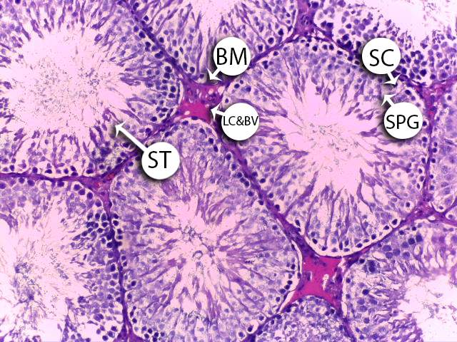
Figure (6): A photomicrograph of a section from rat’s testis of a Selenium treated group showing normal architecture with well-arranged closely matted seminiferous tubule (ST) and normal interstitial tissues which contain Leydig cell and Blood vessels (LC&BV) & normal spermatogonia (SPG) & Sertoli cells (SC) with normal Basement membrane (BM) (Hx & E x 200)
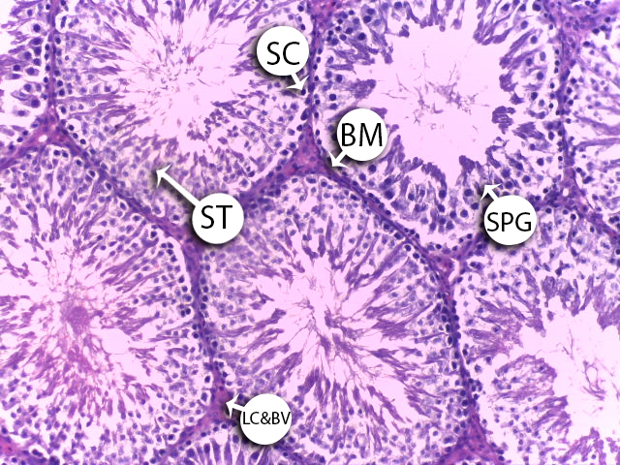
Figure (7): A photomicrograph of a section from rat’s testis of Vitamin C treated group showing normal architecture with well-arranged closely matted seminiferous tubule (ST) and normal interstitial tissues which contain Leydig cell and Blood vessels (LC&BV) & normal spermatogonia (SPG) & Sertoli cells (SC) with normal Basement membrane (BM) (Hx & E x 200).

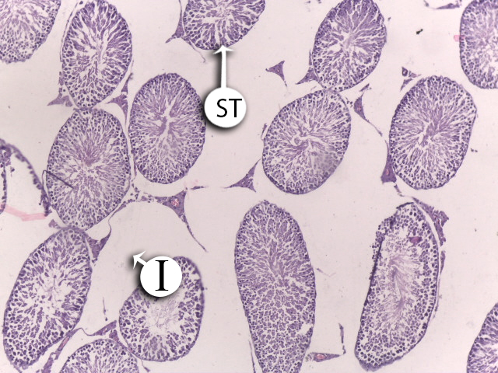
Figure (8): A photomicrograph of a section from rat’s testis of Nicotine treated group showing wide interstitial space, disruption of ST, atrophy of cells, necrosis of spermatocytes, defoliation of many spermatocytes into lumen of the seminiferous tubules (ST) (Hx & E x 100).
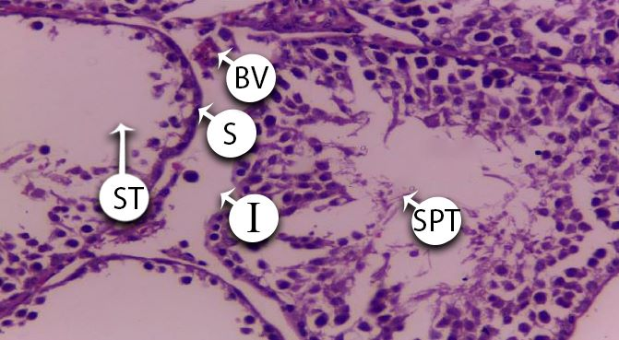
Figure (9): A photomicrograph of a section from rat’s testis of Nicotine treated group showing interstitial edema (I) with congested blood vessel (BV), seminiferous tubules (ST) showed degeneration of germ cells with decrease in spermatid (SPT) count (H&E x 400).

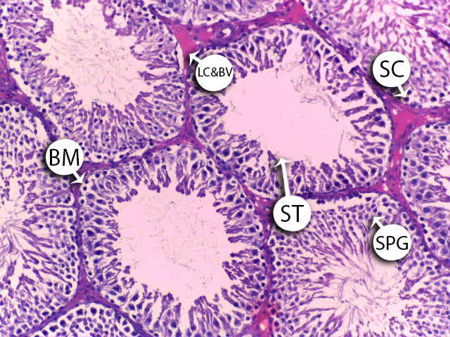
Figure (10): A photomicrograph of a section from rat’s testis of Selenium and Nicotine group showing mild amelioration of normal architecture of seminiferous tubule (ST), decrease in spermatogonia (SPG) and thick basement membrane (BM) (Hx & E x 200).

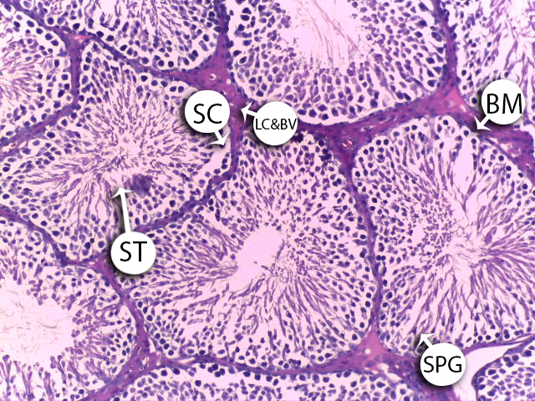
Figure (11): A photomicrograph of a section from rat’s testis of Vitamin C and Nicotine group showing mild amelioration of normal architecture of seminiferous tubule (ST) and thick basement membrane (BM) (Hx & E x 200).

5.DISCUSSION
At the end of the 4th week (Final body weight) there was statistically significant increase was showed in all the studied groups as the body weight increased in all the groups of negative control group, positive control group, Selenium group, Vitamin C group, nicotine with Selenium group, Nicotine with vitamin C group, except the Nicotine group showed decrease in weight. This was in agreement with Abdel-Hamid (2018) who stated that the Body weights of rats, which received nicotine significantly decreased in comparison to the control and nicotine with vitamin C groups. Also, Iranloye and Bolarinwa1 (2009) reported that there was a progressive reduction in the weight of the body following administration of nicotine.
Our results showed that as for the Mean value of testis weight had shown statistically significant difference at the end of the 4 weeks between the studied groups as negative control, positive control, Selenium, Vitamin C, showed slight increase than the Nicotine group. On our side Oyeyipo (2010) showed that that there is a significant decrease in the mean testicular weight on nicotine administration. Seema et al, (2007) also stated that testis weight of the rats was decreased in the nicotine administered group, when compared to the control. On Se supplementation and co-administration of nicotine along with selenium, the weight was increased in comparison to the nicotine group.
Regarding semen analysis our present study showed highly significant reduction in the mean value of Nicotine group when compared with Negative control, Selenium group and Vitamin C group regarding sperm count, motility, Livability and Normal cells while it showed highly significant increase regarding head and tail abnormality. The present work stated that selenium group showed a highly significant difference in the mean value when compared with control group regarding livability. Vitamin C group showed a highly significant difference in the mean value when compared with control group and nicotine group regarding livability, sperm count, motility, normal cells and head and tail abnormality.
In accordance with our results Mosbah et al. (2015) found that the effects of nicotine on semen characteristics as the nicotine markedly affected sperm quality, as evidenced by a significant reduction in spermatids number, sperm count, sperm motility, daily sperm production as well as in testosterone levels; meanwhile, sperm abnormality was increased significantly. In alignment with our study Ezzatabadipour et al. (2012) found that Sperm concentration was comparable between the intact and control groups while a reduction in sperm concentration was observed in all treated groups especially in the nicotine group compared to either the intact or control groups. Nicotine with selenium group and Nicotine with Vitamin C showed a highly significant difference in the mean value when compared with control group and nicotine group regarding livability, sperm count, motility, Livability, normal cells and head and tail abnormality.
In the line of our results Vijayam et al. (2014) stated that there was increased abnormalities of sperm head in nicotine treated rats compared to control ensured the detrimental effect of nicotine on spermatozoa. Kaur and Bansal (2005) observed reduction in the reproductive ability of selenium deficient mice. Selenium plays a major role in the spermatogenesis especially through the selenoenzyme phospholipid glutathione peroxidase (PHGPx, GPx-4). In line with the results of this study, Okon et al (2016) they concluded that vitamin C has a strong effect on male reproductive morphology.

On the behalf of the hormonal parameters, we found that regarding the Follicular stimulating hormone (FSH) there was no statistically significant difference between all the compared groups as we found that it was elevated in the nicotine group while decreased with selenium only administration. Regarding Luteinizing hormone (LH) Nicotine group showed statistically significant increase in the mean value when compared with Negative control group, selenium group and Vitamin C group. Vitamin C showed statistically significant decrease when compared with the nicotine group. Also, Nicotine with selenium group and Nicotine with Vitamin C group showed statistically significant decrease when compared with the nicotine group. As for Free testosterone Nicotine group showed statistically significant decrease in the mean value when compared with Negative control group and selenium group. Vitamin C group showed statistically significant increase when compared with nicotine group. Nicotine with selenium group, Nicotine with Vitamin C group showed statistically significant increase when compared with the negative control group and nicotine group. Our present study showed that co-administration of selenium with nicotine had better results than vitamin C with nicotine.
Regarding the nicotine results on our side, Sydney and Theresa (2015) serum levels of LH and FSH were increased in treated in tobacco smoke, smokeless tobacco, and nicotine exposed rats. These findings are also in agreement with Heidary et al., (2012) findings which has stated that the results indicated that serum FSH level was insignificantly increased in hookah and significantly increased in cigarette smoking rats compared with control animals. This finding was in acc0rdance with Trummer , et al (2002) who showed that the mean serum testosterone level of rats that received (low dose) and those that received (high dose) of nicotine for four weeks was significantly decreased when compared with the control group. Our findings were c0nsistent with Eissenberg and Shihadeh (2009) results as they found that serum levels of testosterone were decreased in cigarette or hookah smoking rats compared with control animals.
Notifying to the selenium results Chattopadhyay et al. (2003) found that selenium supplementation along with nicotine treatment resulted in hormonal levels (FSH,LH and Testosterone) near the basal levels, similar to the control group and this was explained by an hypothesis is that nicotine-induced reproductive toxicity may be due to the induction of oxidative stress or free radical generation, and, since selenium is an important dietary antioxidant, it may prevent this toxicity by its free radical scavenging action.
Regarding Vitamin C results Azeez (2021) stated that in rats treated with nicotine alone, the level of FSH and LH was decreased by 29%. In addition, as compared to the control and nicotine groups while Nicotine +vit C resulted in substantial reductions in FSH, LH levels of 21% and 12%, respectively as he found that vit C protects the testes from the toxicity of nicotine and discovered that vit C had antioxidant properties. Vitamin C substantially decreased mRNA damage, increased the quality of sperm produced, testicular antioxidant and endocrine condition.

Regarding hematological parameters we found that regarding red cell count and hemoglobin there was statistically significant decrease of the mean value of nicotine when compared with the control groups, Selenium group, Vitamin C group. Moreover, the coadministration of selenium or Vitamin C or Nano with nicotine showed statistically significant increase red cell count and hemoglobin when compared with the nicotine group only as it was significantly statistical elevated mostly with Coadministration of selenium with nicotine. Our present study showed that co-administration of selenium with nicotine had better results in red cell count and hemoglobin than vitamin C with nicotine. Regarding Total leukocyte count showed statistically significant increase of the mean value of nicotine group when compared with the control group. Vitamin C group, Coadministration of selenium or Vitamin C or Nano selenium group with nicotine showed statistically significant decrease when compared with the nicotine group, but the mean value was still higher than control group (showed a highly significant difference with control) while depressed mostly with Coadministration of Vitamin C with nicotine.

On our side Atawal et al. (2020) stated that the Nicotine group compared to the negative control group showed decrease in packed cell volume, hemoglobin concentration, red blood cells, and lymphocytes reduced dose-dependently in contrast to the white blood cells and neutrophils that increased.
Also, Rajasekhar et al. (2007) stated that the decrease in RBC and an increase in WBC counts of the experimental rats compared to the controls.
Also, in agreement to our study Abouelghar et al. (2020) The results of treatment of mice via oral administration with selenium for 2 weeks, showed beneficial effects by increasing the levels of hematological parameters: RBC, Hemoglobin (HGB).
Our finding was in acc0rdance with Mongi et al. (2011) who showed that the Vitamin C supplementation to nicotine treated rats reversed these abnormal hematological effects and attained the hematological parameter changes to normal levels because of the approved protective effects of vitamin C dietary supplementation against various pathologies.

In our results we found that the oxidative parameters showed that regarding MDA concentrations in tissue there was statistically significant increase of the mean value of nicotine when compared with the control group and selenium group. Vitamin C group statistically significant decrease when compared to the nicotine group. We found that the coadministration of Selenium, vitamin C with nicotine showed statistically significant decrease when compared with the nicotine group only and significant increase than the control group as coadministration of selenium with nicotine showed the best results. As for CAT concentrations in tissue we found that there was statistically significant decrease of the mean value of nicotine when compared with the control group. The coadministration of selenium and vitamin C with nicotine showed statistically significant increase when compared with the nicotine group and control group as the coadministration of selenium with nicotine showed the best results. Regarding GSH concentrations in tissue in the present study there was statistically significant decrease of the mean value of nicotine when compared with the control group. Vitamin C group showed statistically significant increase when compared to the nicotine. The coadministration of selenium and vitamin C with nicotine showed statistically significant enhancement in the results when compared with the nicotine group, but the mean value was still lower than control group. Regarding SOD concentrations in tissue, we stated that statistically significant decrease of the mean value of nicotine when compared with the control group, The coadministration of selenium and Vitamin C with nicotine showed statistically significant increase.
On our side Jana et al., (2010) stated that the testicular content of MDA, the product of lipid peroxidation of the polyunsaturated fatty acid present in cell membrane, was significantly elevated concomitantly with significant increase in the generation of testicular hydrogen peroxide (H₂O₂) and hydroxyl radicals (OH__) after chronic nicotine exposure with respect to the controls, indicating the testicular ROS generations and induction of oxidative stress and also it has been shown that the amount of the GSH significantly decreased with nicotine treatment in the testis with respect to the control reflecting a state of apparent oxidative stress.
Similarly, to our results Mendelson et al. (2003) noted that the results showed a significant reduction in the levels of GSH and in the CAT and SOD activities in the Nicotine group; in the antioxidant group, CAT and SOD activities were significantly increased. On the other hand, the mean values of oxidative stress indicators in the Nicotine and antioxidant group were not significantly different from control group.
Selenium (Se) supplementation may prevent the formation of free radicals and the process of lipid peroxidation (El-Demerdash and Nasr, 2014). It has been detected that Se act as a substrate for various enzymes such as Glutathione Peroxidase and is important in Sulphur amino acid metabolism that protects the body against several diseases through their antioxidant role. The protective effect of selenium against nicotine induced tissue damage could be attributed to it is own antioxidant activity and enhancement of the cellular antioxidant enzymes (Lamia S et al., 2010).
While Zhuo et al (2010) stated that they found that Catalase activity (CAT) were declined significantly due to nicotine administration compared to the control group. Supplementation with Vitamin C to nicotine treated groups caused increased CAT activity to normal levels. In addition, treatment with Selenium increased the CAT activity but still higher than those of control group.
Referring to the histopathology, the examination of the testes by H&E-stained sections examined under the power 100 and 400 of control rats (positive and negative) showed normal histological architecture. Testis of rat group treated with Nicotine alone showed marked loss of testicular tissue architecture seminiferous tubules with some spermatogonia not in order as in control rats. While in rat group received Vitamin C concomitant with Nicotine mild improvement in histopathological findings was detected as there was mild restore to architecture of seminiferous tubules. However, in rat group received Selenium concomitant with Nicotine, the improvement in histopathological findings was less than that was seen in Vitamin C treated group.
In the line of our findings Owumi and Dim (2019) showed that microscopic examination revealed normal architecture of testis of control rats. Testis from rats treated with toxic substance alone showed severe congestion of the interstitium, whereas testis of Selenium only treated rats showed no visible lesions.
In agreement to our results Meltem et al. (2007) stated that the spermatogenic cells and Sertoli cells in the seminiferous tubules of vitamin C treated group and control group rats were observed in normal structure. Also, Ahama and Odokuma (2022) noted that the tubules vary in size and are separated by a loose fibrovascular connective tissue stroma which are sheets of interstitial cells. The seminiferous tubule is lined by stratified germinal epithelium composed of a basal spermatogonia layer, spermatocytes and spermatozoa disposed to the luminal aspects. Sertoli cells are apparent between these parenchyma cells.
6. CONCLUSION
Based on our satisfactory and promising results this study suggests that Oral administration of Nicotine induced toxic effects, hormonal changes and hematological damage in the testes and these adverse effects may be attributed to induction of oxidative stress as Nicotine increases ROS by breaking the mitochondrial respiratory chain and inhibits testosterone biosynthesis in mouse Leydig cells the nicotine enhanced ROS production impairs steroidogenesis at the first step of cholesterol transfer to the mitochondria by suppressing the steroidogenic acute regulatory protein expression. This advances in administration of Selenium and Vitamin C with Nicotine, protected against Nicotine damaging effect can be used as very important tools in toxicological practice.
7. RECOMMENDATIONS
Depending on the results of this study, the following guidelines are
recommended:
- Establishing a national policy that restrict Nicotine use in all theatres.
- Health education efforts on smoking should also address the empowerment of nonsmokers and should include culturally appropriate ways to express their desire for a smoke-free environment.
- Widespread public education regarding the health hazards of Cigarette smoking with a special concern about its reproductive toxic effects.
- Developing an evidence-based smoking cessation message.
- Dietary intake of Selenium supplements with increase intake of food and fruits rich in Selenium is very essential as it works as a potent antioxidant that can reverse oxidative damage inside the tissue.
- Regular use of vitamin C in case of male infertility as apart of treatment is helpful for improvement of testicular integrity and hormonal function.
8. CONFLICTS OF INTEREST
The authors declare no conflict of interest.
9. ACKNOWLEDGEMENT
Our deep appreciation to the staff members of Forensic Medicine and Clinical Toxicology, Faculty of medicine, Benha University.
10. REFERENCE
- Abdel-Hamid GA (2018): Ameliorative effect of vitamin C on nicotine-induced histological and ultrastructural changes in zona fasciculata in albino rats Anat & Physiol. ;5(2):120‒125.
- Abouelghar G E., El-Bermawy ZA and Salman HMS et al (2020): Oxidative stress, haematological and biochemical alterations induced by sub-acute exposure to fipronil in albino mice and ameliorative effect of selenium plus vitamin E. Environmental Science and Pollution Research; 27:7886–7900.
- Atawal AF, Okwuonu ES and Melefa TD et al. (2020): The Consequence of Aqueous Extract of Tobacco Leaves (Nicotiana tabacum. L) on Feed Intake, Body Mass, and Hematological Indices of Male Wistar Rats fed under Equal Environmental Conditions;40(5).
- Azeez OH (2021): Evaluation of Some Male and Female Rats’ Reproductive Hormones Following Administration of Nicotine with or Without Vitamin C or E Vet. Med; 45(2):14-20.
- Bearden JH and Fuquay JW (1984): Applied animal reproduction. Reston publishing company inc. A prentice Halls Company Virginia. 341-345.
- Carstens E and Carstens MI (2021): Sensory Effects of Nicotine and Tobacco, Nicotine Tob, Philos. Phenomenol. Res.; (2021): 1–10.
- Chattopadhyay S, Pal S and Ghosh D, et al (2003): an Effect of Dietary Co-Administration of Sodium Selenite on Sodium Arsenite-Induced Ovarian and Uterine Disorders in Mature Albino Rats. Toxicological sciences; 75:412–422.
- Chen L, Hu C and Hood M, et al. (2020): A novel combination of vitamin C, curcumin and glycyrrhizic acid potentially regulates immune and infammatory response associated with coronavirus infections: a perspective from system biology analysis. Nutrients.;12(4):1193.
- Deniz B, Rupprecht L.E and Nunes E.J., et al (2021): Evaluation of Flavor Effects on Oral Nicotine Liking and/or Disliking Using the Taste Reactivity Test in Rats. Nicotine Tob, Philos. Phenomenol. Res; (2021) 1–8.
- Efe AE and Igho OE (2022): Histomorphological Effects of Oral Nicotine Administration on the Testes of Adult Wistar Rats Journal of Chemical Health Risks 12(0).
- Eissenberg T and Shihadeh A. (2009): Hookah Tobacco and Cigarette Smoking Direct Comparison of Toxicant Exposure. Am J Prev Med;37(6):518-23.
- El-Demerdash FM and Nasr HM. (2014): Antioxidant effect of selenium on lipid peroxidation, hyperlipidemia and biochemical parameters in rats exposed to diazinon. J Trace Elem Med Biol; 8:89–93.
- Evans G and Maxwell WMC (1987): Handling and examination of semen. In: Salamon’s artificial insemination of sheep and goats. Maxwell WMC, (eds). Sydney, Australia: Butterworths, Pp: 93-106.
- Ezzatabadipour M, Azizollahi S and Sarvaza A, et al (2012): Effects of concurrent chronic administration of alcohol and nicotine on rat sperm parameters. Andrologia; 44: 330–336.
- Feldman AT and Wolfe D (2014): Tissue processing and hematoxylin and eosin staining. Methods Mol Biol; 1180:31-43.
- Heidary F, Ahmadi R and Lotfi A (2012): The Effects of Cigarette or Hookah Smoking on Serum Levels of LH, FSH or Testosterone in Male Rats. International Conference on Medical, Biological and Pharmaceutical Sciences; 12:103-105.
- Iranloye B. O. and Bolarinwa1 A. F. (2009): effect of nicotine administration on weight and histology of some vital visceral organs in female albino rats. Nigerian journal of physiological sciences; 24 (1): 7 – 12.
- Jana K, Samanta PK and Kumar D, et al. (2010): Nicotine Diminishes Testicular Gametogenesis, Steroidogenesis, and Steroidogenic Acute Regulatory Protein Expression in Adult Albino Rats: Possible Influence on Pituitary Gonadotropins and Alteration of Testicular Antioxidant Status. TOXICOLOGICAL SCIENCES; 116(2): 647–659.
- Kaur P, Bansal MP (2005): Effect of selenium-induced oxidative stress on the cell kinetics in testis and reproductive ability of male mice. Nutrition 21:351–357.
- Lamia S, Mohamed B and Abdelhamid K et al. (2010): Influence of combined treatment with zinc and selenium on cadmium induced testicular pathophysiology in rat. Food Chem Toxicol; 48:2759–65.
- Leventhal A, Dai H and Barrington-Trimis J (2023): ‘Ice’ flavoured e-cigarette uses among young adults. Tobacco Control.; 32(1): 114–117.
- Meltem U, Yusuf K and Kerem Det al. (2007): Acute, subacute and subchronic administration of methyl parathion-induced testicular damage in male rats and protective role of vitamins C and E Pesticide Biochemistry and Physiology; 87: 115–122.
- Mendelson JH, Scholar MB and Mutschler NH et al. (2003): of intravenous cocaine and cigarette smoking on luteinizing hormone, testosterone, and prolactin in men. J Pharmacol Exp Ther; 307:339–48
- Mongi S., Messarahb M and Boumendje A et al. (2011): Protective effects of vitamin C against haematological and biochemical toxicity induced by deltamethrin in male Wistar rats Ecotoxicology and Environmental Safety 74 1765–1769.
- Mosbah R, Yousef MI and Mantovani A et al. (2015): Nicotine-induced reproductive toxicity, oxidative damage, histological changes and haematotoxicity in male rats. The protective effects of green tea extract Experimental and Toxicologic Pathology; 67:253–259.
- Okon U and Utuk I, (2016): “Ascorbic acid treatment elevates follicle stimulating hormone and testosterone plasma levels and enhances sperm quality in albino Wistar rats,” Nigerian Medical Journal; 57 (1):31.
- Owumi SE and Dim UJ (2019): Biochemical alterations in diclofenac-treated rats: Effect of selenium on oxidative stress inflammation, and haematological Changes Toxicology Research and Application; 3: 1–10.
- Oyeyemi MO, Olukole SG and Ajayi TA et al., (2011): Semen characteristics and sperm morphological studies of the West African Dwarf Buck treated with Aloe vera gel extract. Iran J Reprod Med. 9(2): 83-88.
- Oyeyipo I.P., Raji Y. and Emikpe B.O. et al (2010): Effects of Oral Administration of Nicotine on Organ Weight, Serum Testosterone Level and Testicular Histology in Adult Male Rats Nig. J. Physiol. Sci; 25: 81– 86.
- Picard M, Rossier C, Papasouliotis O et al., (2008): Bioequivalence of recombinant human FSH and recombinant human LH in a fixed 2:1combination: two phase I, randomised, crossover studies. Cur Med Res Opin. 24(4): 1199-1208.
- Rajasekhar G, Ramgopal M and Sridevi A (2007): Some hematological and biochemical parameters in smokeless tobacco (Jharda) chewers. African J Biotech; 6:53-4.
- Seema P, S. S. Swathy and M. Indira et al. (2007): Protective Effect of Selenium on Nicotine-Induced Testicular Toxicity in Rats. Biol Trace Elem Res; 120:212–218.
- Sydney A and Theresa U (2015): Comparative Evaluation of the Impact of Subacute Exposure of Smokeless Tobacco and Tobacco Smoke on Rat Testis. International Journal of Reproductive Medicine; 15:1- 10.
- Tannous S, Darlot F and Cador M, et al. (2021): Flavor additives facilitate oral self-administration of nicotine solution in mice. Psychopharmacology (Berl); 238 (2021): 2235–2247.
- Trummer H, Habermann H and Haas J, et al., (2002): The impact of cigarette smoking on human semen parameters and hormones. Hum Reprod; 17:1554-9.
- Urbano T, Filippini T and Wise LA et al. (2023): Selenium exposure and urinary 8-oxo-7,8-dihydro-2′-deoxyguanosine: Major effects of chemical species and sex. Science of the Total Environment; 870 (2023): 161584.
- Vijayam S, Nair G and Rajamohan TH et al. (2014): The Role of Coconut Water on Nicotine-Induced Reproductive Dysfunction in Experimental Male Rat Model Food and Nutrition Sciences;5: 1121-1130.
- Vinceti M, Bonaccio M and Filippini M, et al. (2021): Dietary selenium intake and risk of hospitalization for type 2 diabetes in the Moli- Sani study cohort. Nutr. Metab. Cardiovasc. Dis.; 31: 1738–1746.
- Yoo J, Kim R and Ju S, et al. (2020): Clinical impact of supplementation of vitamins B1 and C on patients with sepsis-related acute respiratory distress syndrome. Tuberc Respir Dis.;83(3):248–54.
- Zhuo X, Xie F and Kluetzman K, et al. (2010): Role of CYP2A5 in the clearance of nicotine and cotinine, insights from studies on a Cyp2a5-null mouse model, J. PharmacolExp. Ther.; 332:578–587.

